**Week 1 –Asynchronous Activities**

**Greeting and introductions**

1. Watch until 2:51 in the video and then go to <https://www.liveworksheets.com/kb1470268sj> and solve the video activity from [Top Notch Fundamentals - Unit 2](https://www.youtube.com/watch?v=VsvTfkDudOM).

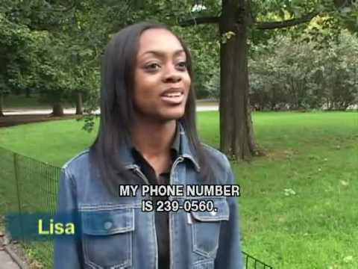

2. With another classmate, record a conversation in a video where you use greetings and introduce yourself giving basic personal information. Be ready to share your video with the class.

**Possessive Pronouns and Adjectives**

1. Go to the following pages:

<https://www.grammar.cl/Notes/Possessive_Adjectives.htm>

<https://www.grammar.cl/Notes/Possessive_Pronouns.htm>

**possessive pronouns**

**Possessive pronouns**

1. Read the information, watch the videos and play the games about Possessive Pronouns and Adjectives.
2. Do the exercises on the next page to check your understanding of the Possessive Pronouns and Adjectives.



**. Check your grammar: multipl**

**1**

**e choice**

**–**

**personal pronouns and possessives**

Choose the correct word to complete the sentences.

1.

Could

**you / her / your**

take a message, please?

2.

They showed us all

**they / their / ours**

holiday photo

s last night.

3.

I’m sorry but these seats are

**my / their / ours**

.

4.

Sandy and

**I / me / her**

are going to the café.

5.

Do you want

**I / me / my**

to turn this off?

6.

I saw your sister’s paintings yesterday.

**She / They / Its**

were very good

.

7.

They’ve got two babies and they take

**they / their / them**

everywhere.

8.

Let

**he / my / him**

help you with that.

**. Check your grammar: error correction**

**2**

**–**

**personal pronouns and possessives**

Correct

the mistakes and write the

sentences on the

line below.

1.

They don’t look like they brothers.

………………………………………………………………………………………………….

2.

It’s your father’s idea, not my.

………………………………………………………………………………………………….

3.

Sam and me went to that concert at the weekend.

……………………………………………………………………………

…………………….

**Grammar**

**videos**

**:**

**Personal pronouns and possessives**

**–**

**exercises**

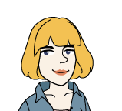

.

Do the next exercises to check your understanding of the Personal Pronouns and Possessives.

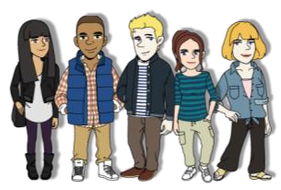

4.

I’ve never met you parents, you know.

………………………………………………………………………………………………….

5.

A: Who's coming to the cinema?

B: Only Paul and my.

………………………………………………………………………………………………….

6.

I would do anything for he.

…………………………………………………………

……………………………………….

7.

My is from a different shop.

………………………………………………………………………………………………….

8.

Have you seen our project? I hope they get an A+.

………………………………………………………………………………………………….

**3**

**. Check your**

**grammar**

**:**

**gap fill**

**–**

**personal pronouns and possessives**

Complete the gaps with a word from the box.

me

he

me

I

me

you

we

its

I

She

you

mine

it

our

us

1.

That’s my brother’s cup and this is ____________. My grandmother gave it to ____________.

2.

Good morning. Can ____________ help ____________?

3.

Ah, there’s Jade’s watch. Could ____________ pass it to ____________? I’ll keep it safe.

4.

That poor dog has lost one of ____________ legs.

5.

Look! I’ve got Poppy’s phone number! She gave ____________ it last night.

6.

____________ don’t mind where

____________ go but ____________ doesn’t like the beach.

7.

____________ never lets ____________ watch TV after 9 p.m.

8.

Do you like ____________ new car? ____________ is second

-

hand.

FIRST GAME

<https://www.grammar.cl/english-games/possessive-adjectives.htm>

I have a book_____ book is new

My

We have a car. ________ car is fast

Our

You have a bike. _______bike is old

Your

He has a shirt. _________shirt is red

His

They have three dogs. ______are noisy

Their

The dog has a bone. Bone is old

Its

She has a pen. _______pen is blue

Her

You have a hat. ______ hat is nice

Your

John has a friend. _____friend is crazy

His

Mary has a magazine. ______ magazine is interesting

Her

Steve and I have food. ___food is yummy

Our

I have an answer. _____answer is correct

My

Mike and peter have shoes. _____ shoes are dirty

Their

You and susan have a piano ____piano is heavy

Your

The cat has a toy. ______toy is broken

Its

Angelica and I have children. _______children are smart

Our

Your grandfather has a camera ______camera is old

His

I have an umbrella ________ umbrella is black

My

My mother has a cake _________cake is delicious

Her

My parents have an apartment. ______apartment is small

Their

SECOND GAME

<https://www.grammar.cl/Games/Possessive_Adjectives.htm>

_____sister lives in Copenhagen

My

I saw ken last night. Do you know it is________bithday ?

His

We need to leave or we will miss______ flight to india

Our

The cat is playing with____ tail

Its

She needs a new computer because _________ old one is broken

Her

Please take _____ time in answering the questions

Your

My friend has a new girlfriend _____ girlfriend is very friendly

His

I am home, honey! Where is ____ dinner?

My

Susan drives _______ car to work

Her

Andrew and Helen have three children _________ children are well behaved

Their

It will rain today Don’t forget to take _________ umbrella

Your

I saw Claudia Schiffer last night. ________ body is incredible!

Her

Did you receive ________ Christmas card I sent you?

My

The students have given _______ teacher a present for her birthday

Their

My husband works very long hours. But, ________ salary is very good

His

_______ life will never be the same after you live overseas

Your

Penny has changed the colour of _______ hair

Her

We have bought _____ parents a holiday in Austria

Our

Can you tell me __________ grade in the exam please?

My

The football team won ____ third championship this year

Their

THIRD GAME

<https://www.grammar.cl/Games/Possessive_Pronouns.htm>

Does this wallet belong to you?

No, it is his

Can i borrow you computer this weekend for my assignment?

No, because mine has broken down

__________ is the best national day in the world

Ours

I found my shoes Mary but we still need to find

Yours

Those gold earnings of________ are stunningly beautiful

Yours

I know you have lost your keys so you can take__________ today

Mine

Do you think his assignment is very good?

No, ours is much better

Have you seen my backpack?

No, mine is here but I haven’t seen yours

My flight arrives at 8:30 pm. What time does______arrive?

Yours

That dog of__________ is barkin again!

Theirs

If you eat ______ there will be nothing left for him

His

Yes officer that child belongs to us. He is one of

Ours

It’s not John’s turn to take the children to soccer. It’s

Yours

By all reports, _________ was a terrible holiday in Greece

Theirs

I know my pronunciation is not good but my wife really needs to practice ____ before we go to Spain

Hers

Unfortunately, _____ is not available but there is another doctor in the clinic to treat your sickness

Ours

I am going to put my winnings in the bank. What would you like to do with?

Yours

There should be a lot of friends at the party. Yes, but none of _____ are coming!

Mine

I presume that ____ is the only possible excuse you will consider

His

If you car has run out of fuel you can take _______ and return it to us tonight

Ours

